Multi2Recycle
Evaluation of the recyclability of flexible food packaging materials in function of their composition and the resulting shelf life of food products (intercluster COOCK project)

Context
Plastic food packaging materials preserve and protect the quality of food products and extend their shelf-life. Seemingly ‘simple’ foils for the packaging of a broad range of food products (e.g. cheese, meat) often consist of multiple layers of different polymers, each contributing their own functionality to the overall packaging. Due to the strong physical attachment of these layers, separation to polymer level is not always possible and thus mechanical recycling is hindered. Therefore, the main valorisation route of these multilayer packages is through incineration with energy recovery. Both on a European and a Belgian level, ambitious objectives for the recyclability of food packages have been formulated. Based on the European Plastic Strategy, 55% of all plastic packaging needs to be recycled by 2030, while the Belgian Food Industry (FEVIA) states that 65% of plastic food packaging should be recycled by 2023. As a consequence, the search for recyclable alternatives with similar functionality has started.

Objectives

“How can a multilayer plastic food packaging be recyclable and at the same time have the optimal barrier properties to ensure the shelf-life of food products?”

The research approach itself consist of two important segments:

1. A knowledge segment: an overview will be given of the latest trends and innovations in the packaging industry and the sorting/recycling industry, relevant to enhance the circularity of food packages.

2. A research segment focussing on selected generic cases and tackling the following topics:
- evaluation of the impact of the packaging composition on the mechanical recyclability of the packaging. Hereby, the aim is to evaluate the mechanical recyclability of foil to foil for secondary (food) packaging and primary non-food packaging applications
- evaluation of the sortability and mechanical recyclability of mixed PP streams (i.e. generic cases).
- evaluation of repetitive mechanical recycling of foil to foil
- defining recycling limits i.e. tolerance level of barrier material for efficient recycling
- evaluation of these recycling limits to ensure that the packaging functionality can still be guaranteed for the selected food products
- evaluation of the recyclability by implementation of a case study at a sorting or recycling company

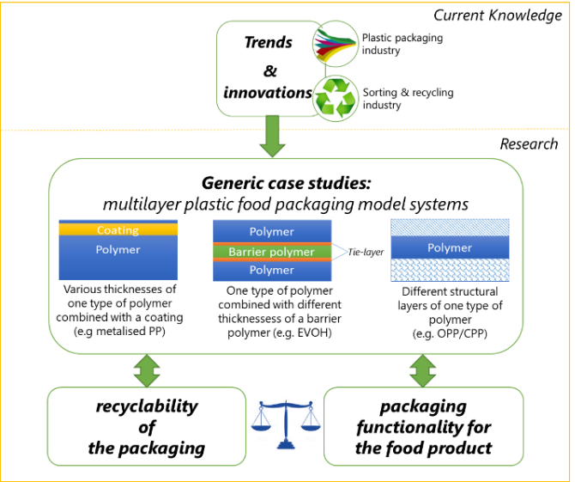
The output of the project should facilitate decisions regarding the design of future packaging and other currently used multilayer plastic food packaging materials.

Target group
This project targets packaging producers and converters, food companies, as well as sorting and recycling companies.

Project consortium
The project consortium (Catalisti, Flanders’ FOOD, Pack4Food, UHasselt and VKC-Centexbel) combines unique and complementary competences in material characterisation, functionalisation, packaging properties, mechanical recycling of polymers and advanced processing techniques. The existing scientific knowledge of the partners will accelerate the step towards industrially relevant, industry-based case studies.

Contact details
Wannes Libbrecht
wlibbrecht@catalisti.be
+32 499 315 604

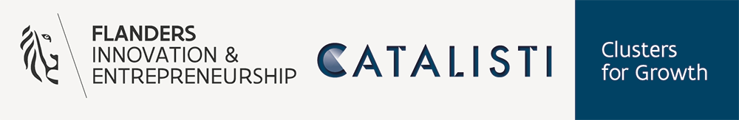

A word of explanation about the project type "COOCK"
COOCK stands for Collective Research and Development and Collective Knowledge Transfer. A COOCK project focuses on groups of companies (~ collective), with the aim of valorising (basic) research results by accelerating the introduction of technology and/or knowledge (~ knowledge transfer).

A COOCK project consists of 2 parts:
- Part A where the project partners, in close collaboration with the participating companies, will select generic packaging systems, determine their recycling limits and link this to the shelf-life of food products - duration: 3 years
- Part B where companies transfer the knowledge gained from part A to their specific application - duration: starts together with part A and continues for 2 years after the end of part A (5 years). Company-specific implementation projects can be:
- Analyzing the mechanical recyclability of a company specific packaging by the procedure demonstrated in part A
- Analyzing a new technology at the company’s or partners’ facilities
- Analyzing a new packaging composition for the company to determine if at least a similar shelf-life of the food can be obtained

Financial contribution to participate to the Industrial Advisory Board

Company size (number of employees) | Annual contribution (excl. VAT)
<10 | 500 €
10 - 50 | 1000 €
50 - 250 | 2000 €
> 250 | 4000 €

Note: To participate in the project, companies need to be a member of at least one of the participating partner organisations, i.e. Flanders’ FOOD, Catalisti, Pack4Food or VKC-Centexbel, and this for at least the duration of the project execution.

Declaration of Intent

The undersigned declares to have taken note of the project application

Multi-2-Recycle: Evaluation of the recyclability of flexible food packaging materials in function of their composition & the resulting shelf life of food products

submitted in the context of the COOCK 2021 call to VLAIO.

Organisation
VAT and address
Flemish SME? | Yes/no (if not, add type of organisation)
Nr. of employees | <10 – 10-50 – 50-250 – >250
Name and function
contact person
Phone
e-mail

Upon approval of the project, the organisation submitted is prepared to cooperate and to enter into concrete agreements in rules of procedure of the support group for the following reasons:

Application

Expectations

Impact/importance

If the project delivers successful results, the organisation will consider setting up a company-specific implementation project.

Name & signature Date

Please send back to Wannes Libbrecht (wlibbrecht@catalisti.be).

